**CONFLICT Git Hub ONLINE**

I did same task but in different order. Sanna2017 updated, pulled request, EmmaK2020 merged to master. Same process for Ade. NO CONFLICT. Conflict happen when 2 pull requests are waiting to be solved.

<https://www.youtube.com/watch?v=oPpnCh7InLY> **he did branches in own project, when I did my both branches merged without conflict**

* EmmaK2020 had created two files in project CONFLICT2: maths and English. In maths she wrote 2 + 2 = 4.
* Sanna2017 has FORKED project CONFLICT2 and created branch in which she amended maths 2 + 2 = 5. She **pull request.**
* Ade12345678 has FORKED project CONFLICT2 and created branch and amended maths 2 + 2 = 8 and deleted English. He also sent **pull request.**

|  |  |  |  |  |  |  |  |  |  |  |  |  |  |  |  |  |  |  |  |  |
| --- | --- | --- | --- | --- | --- | --- | --- | --- | --- | --- | --- | --- | --- | --- | --- | --- | --- | --- | --- | --- |
| |  |  | | --- | --- | | EmmaK2020 | master | | maths | Eng | | 2+2=4 |  | | |  |  | | --- | --- | | SannaK2017 | branch | | maths | Eng | | 2+2=5 |  | | |  |  | | --- | --- | | Ade12345678 | master | | maths | ~~Eng~~ | | 2+2=8 |  | |

**EmmaK2020**

PART 1 – creating files under Master branch

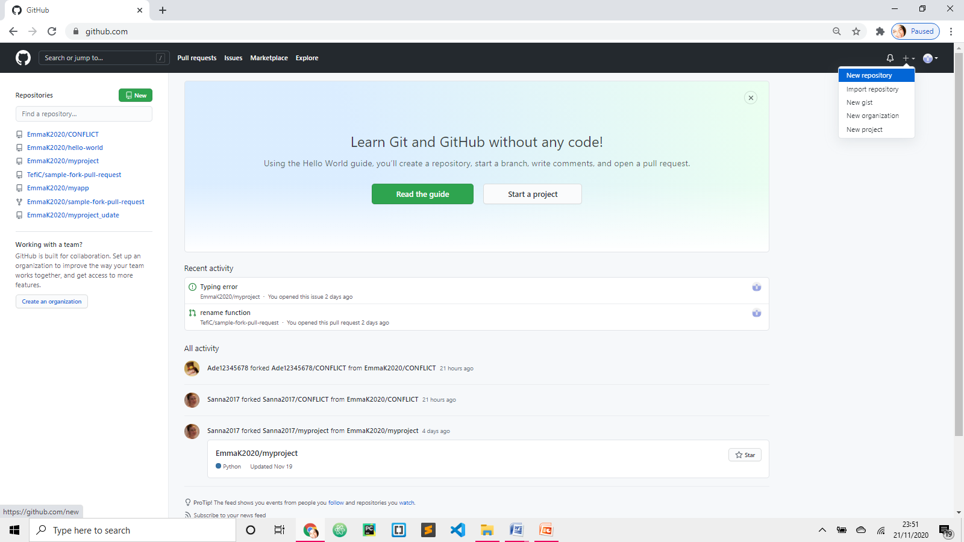

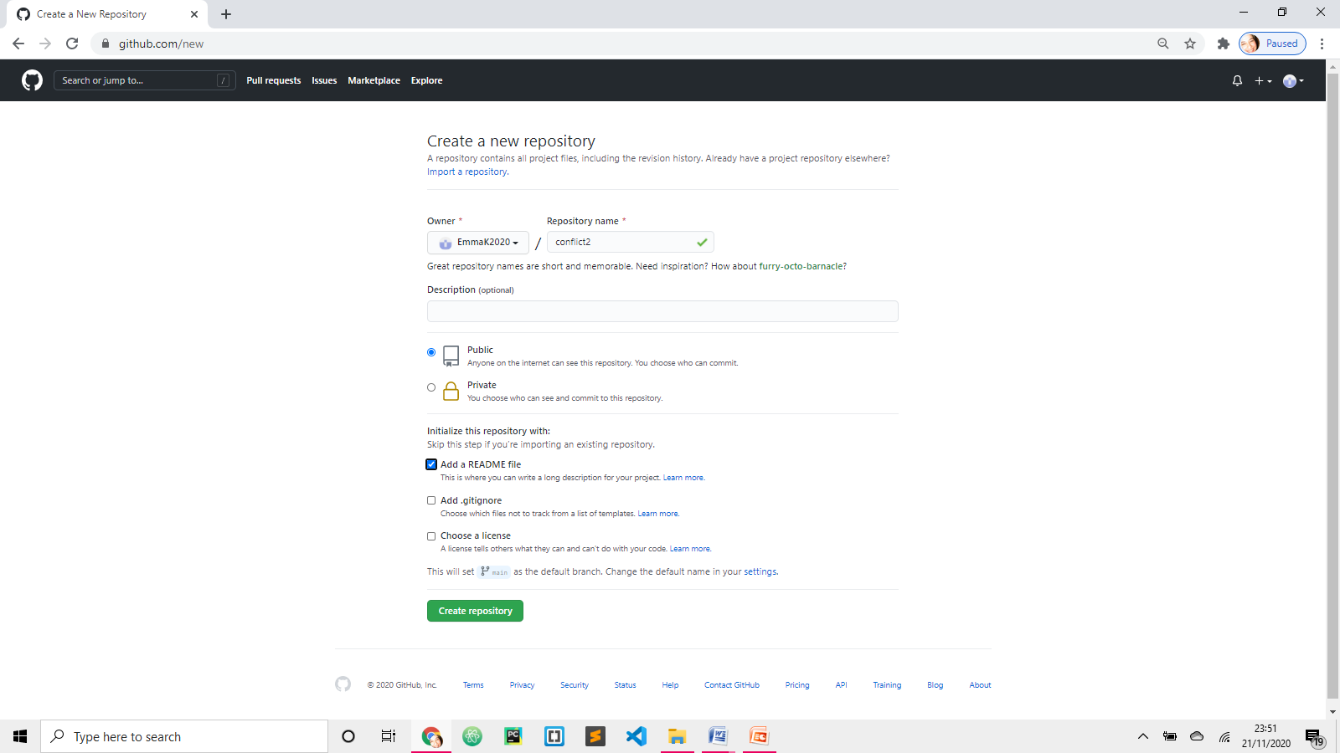

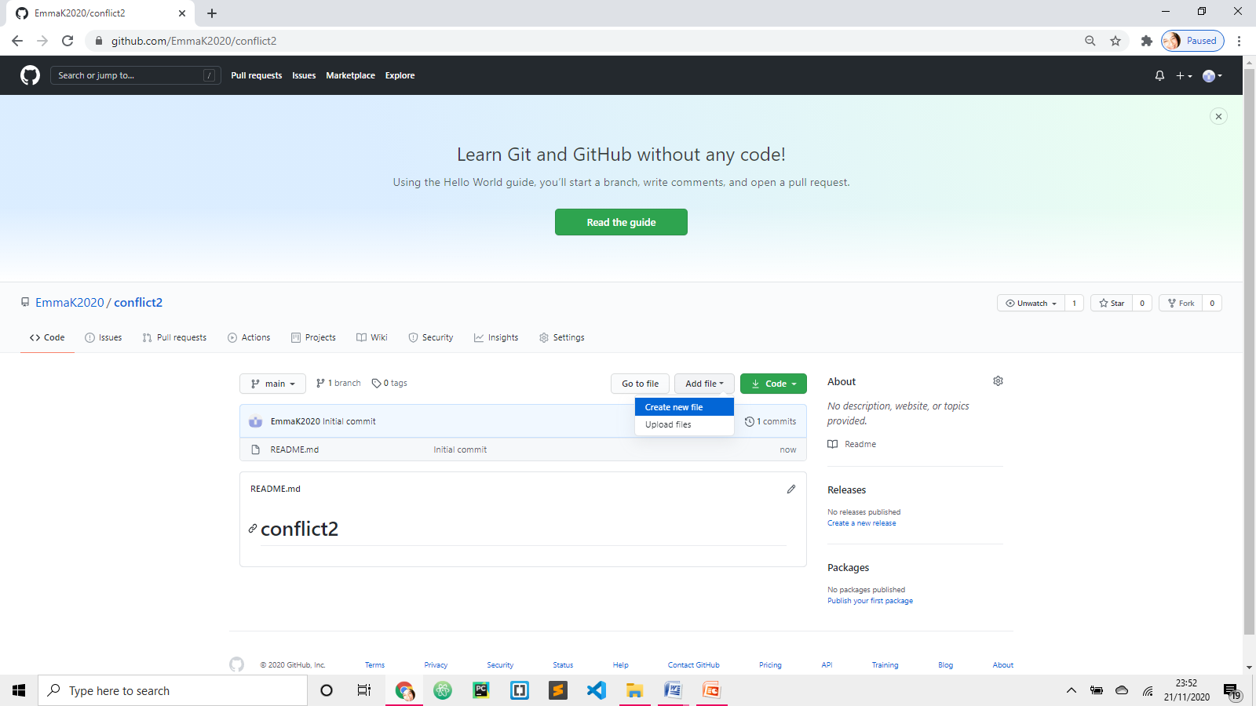

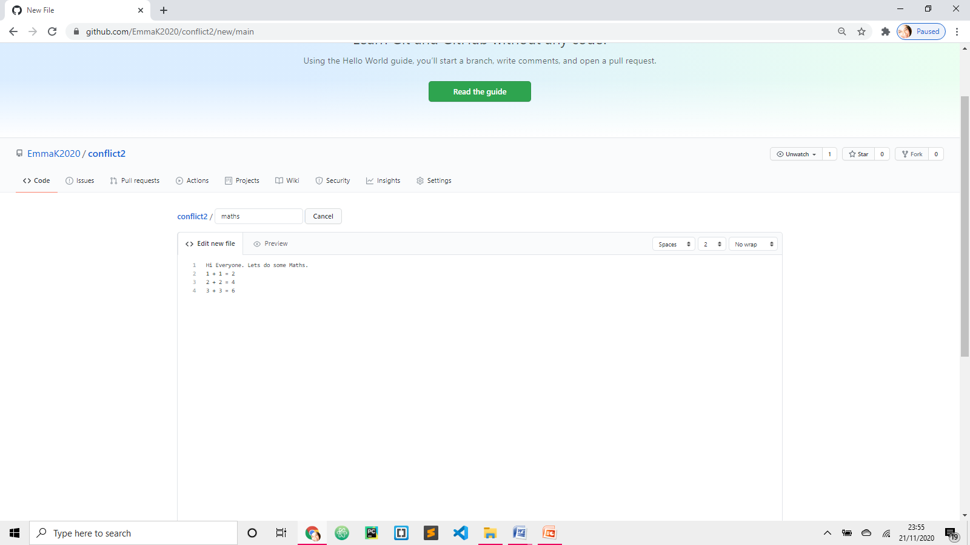 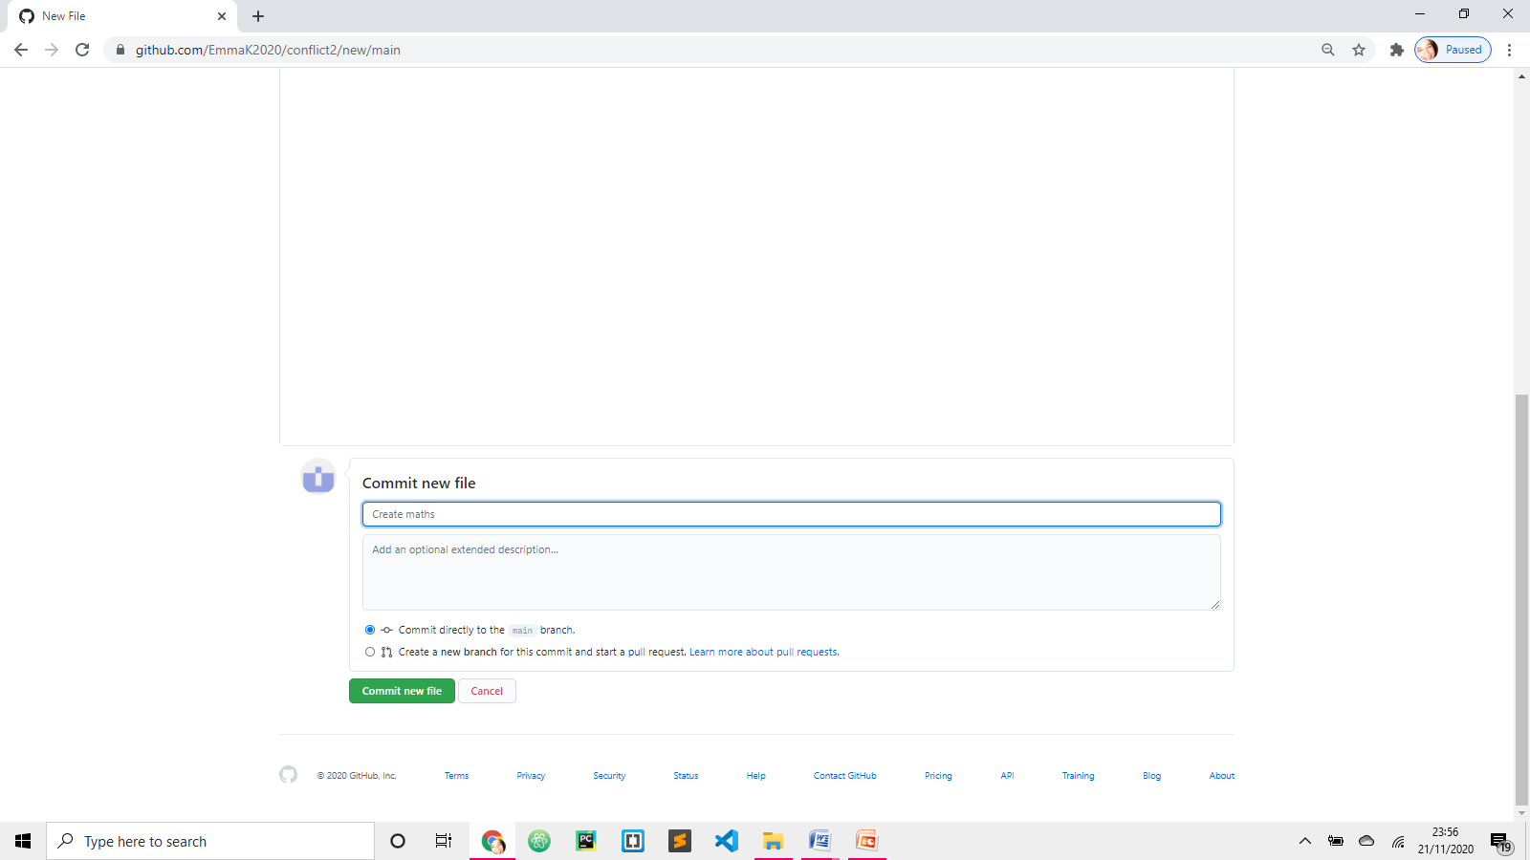

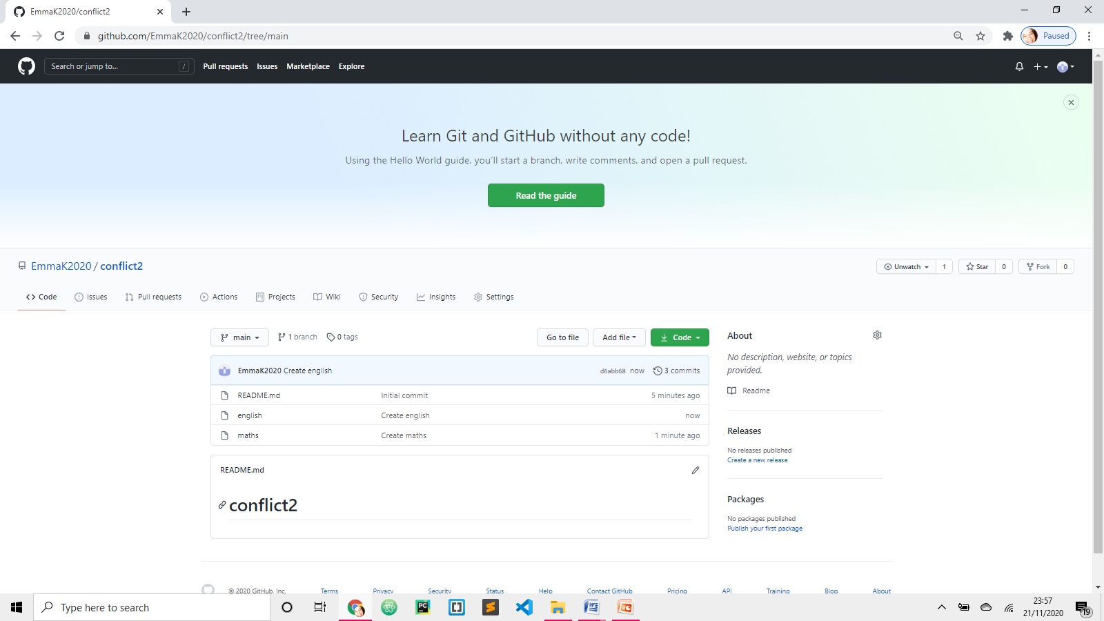 In the same way add one more file and call it English

**Sanna2017**

PART 2 – Fork Emma’s project

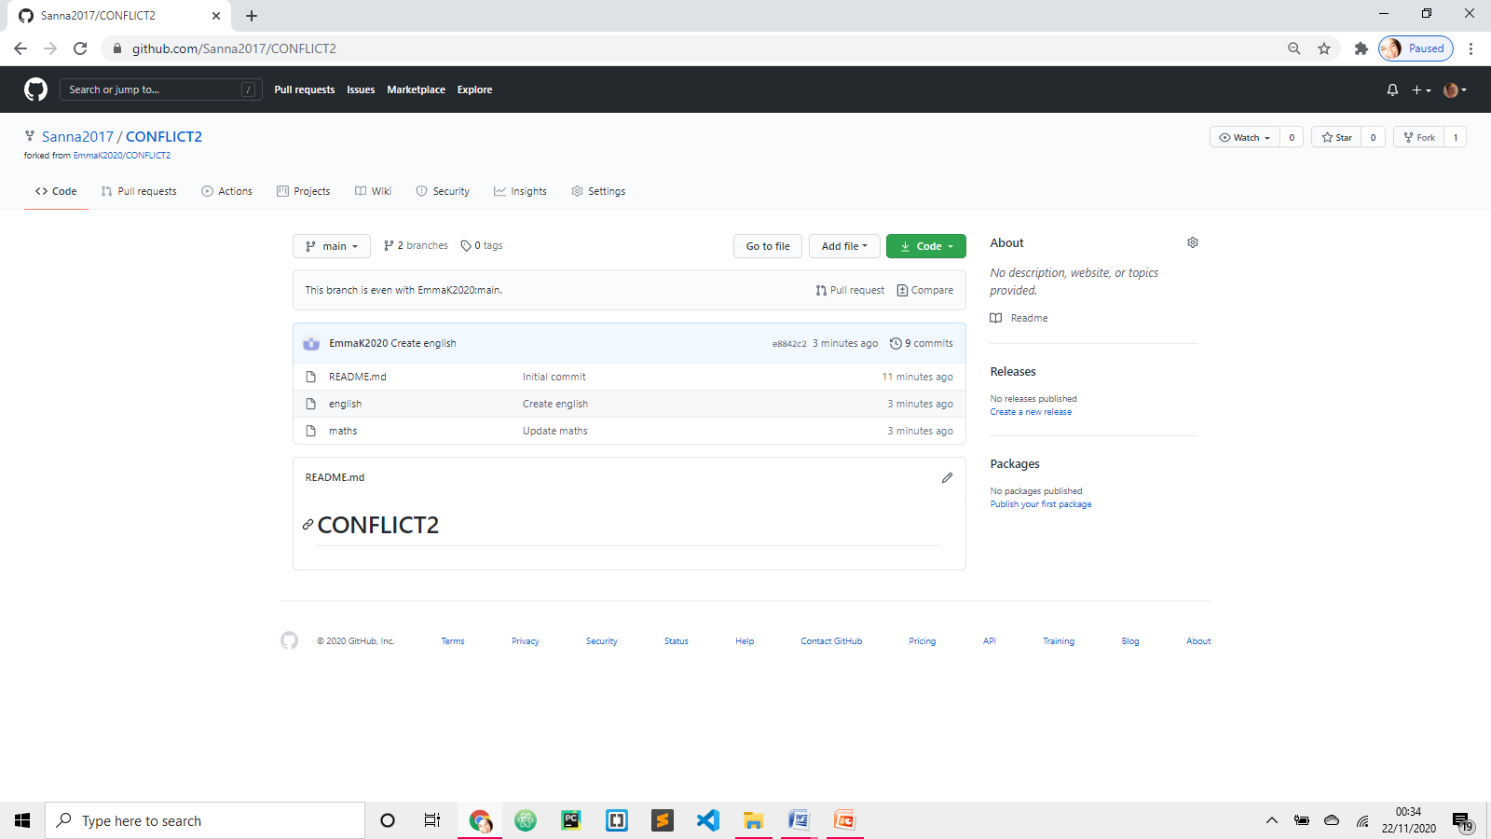 Browse EmmaK2020 CONFLICT2 project and FORK it

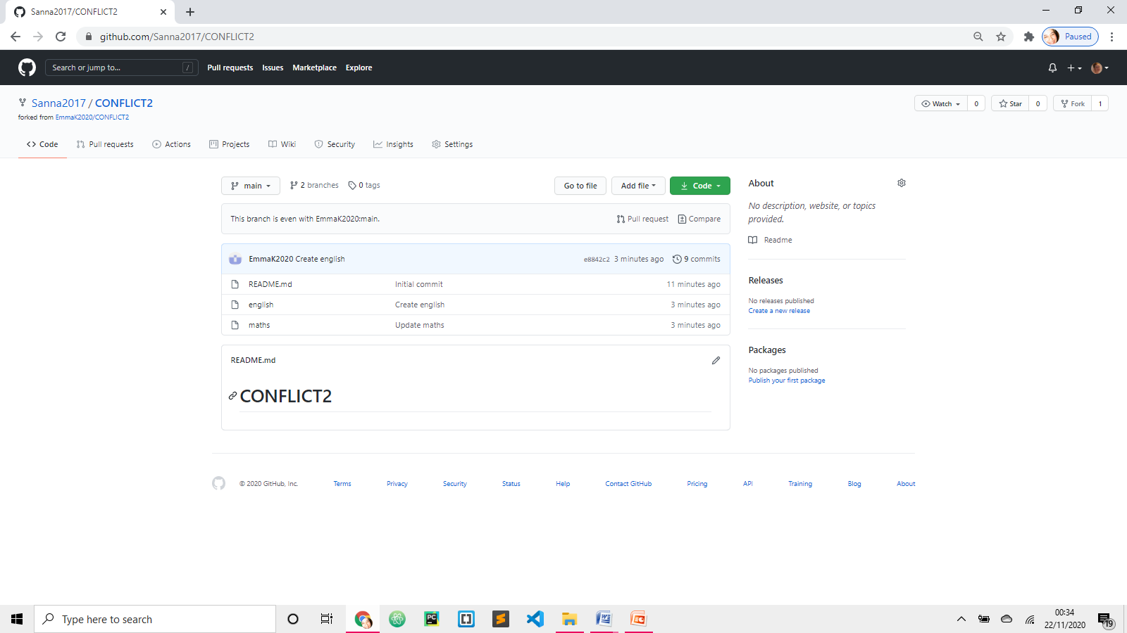

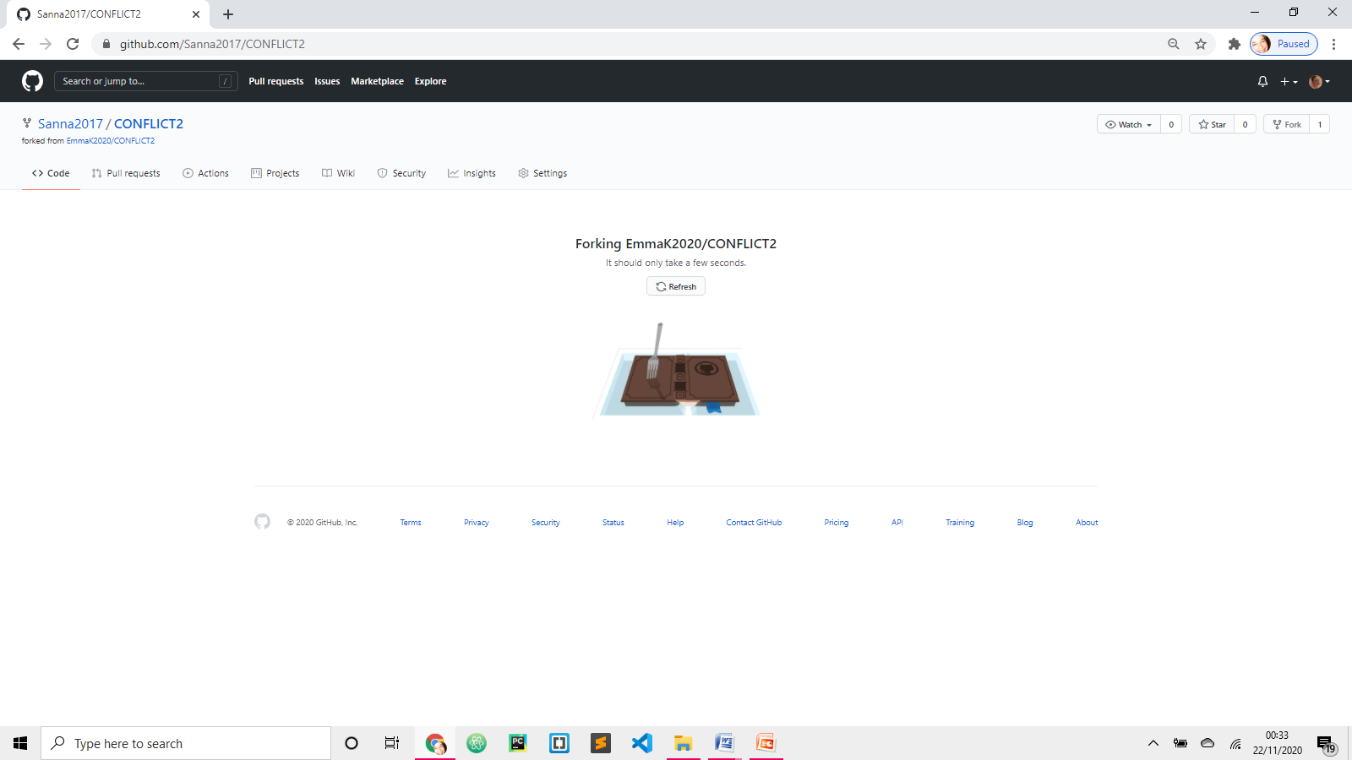

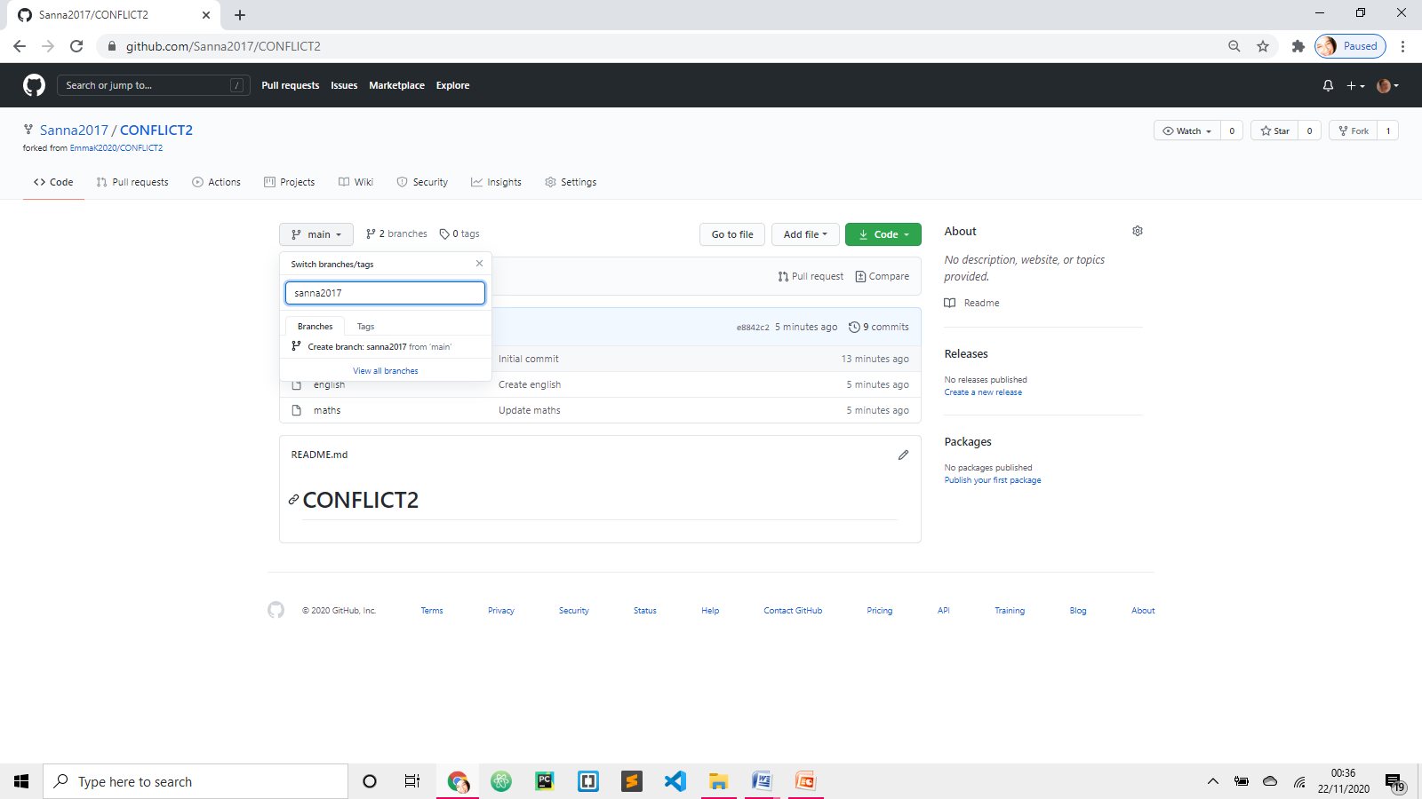 Create branch sanna2017

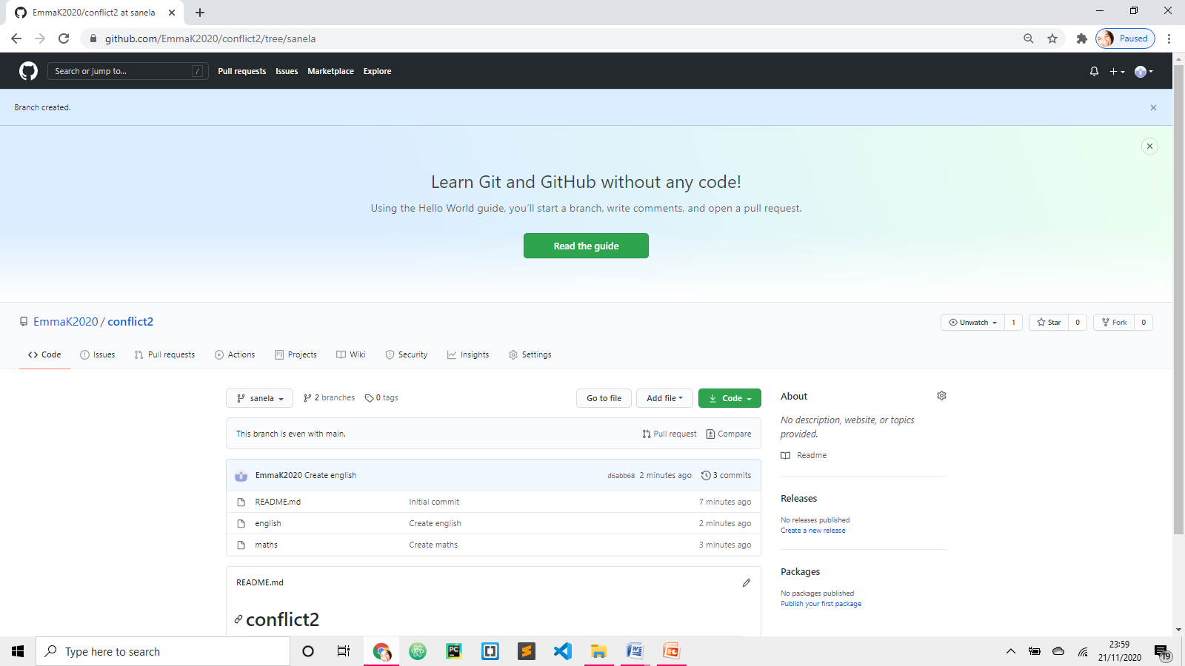 Sanna2017 has access to ALL files from Master

PART 3 – Sanna2017 amending file “maths”

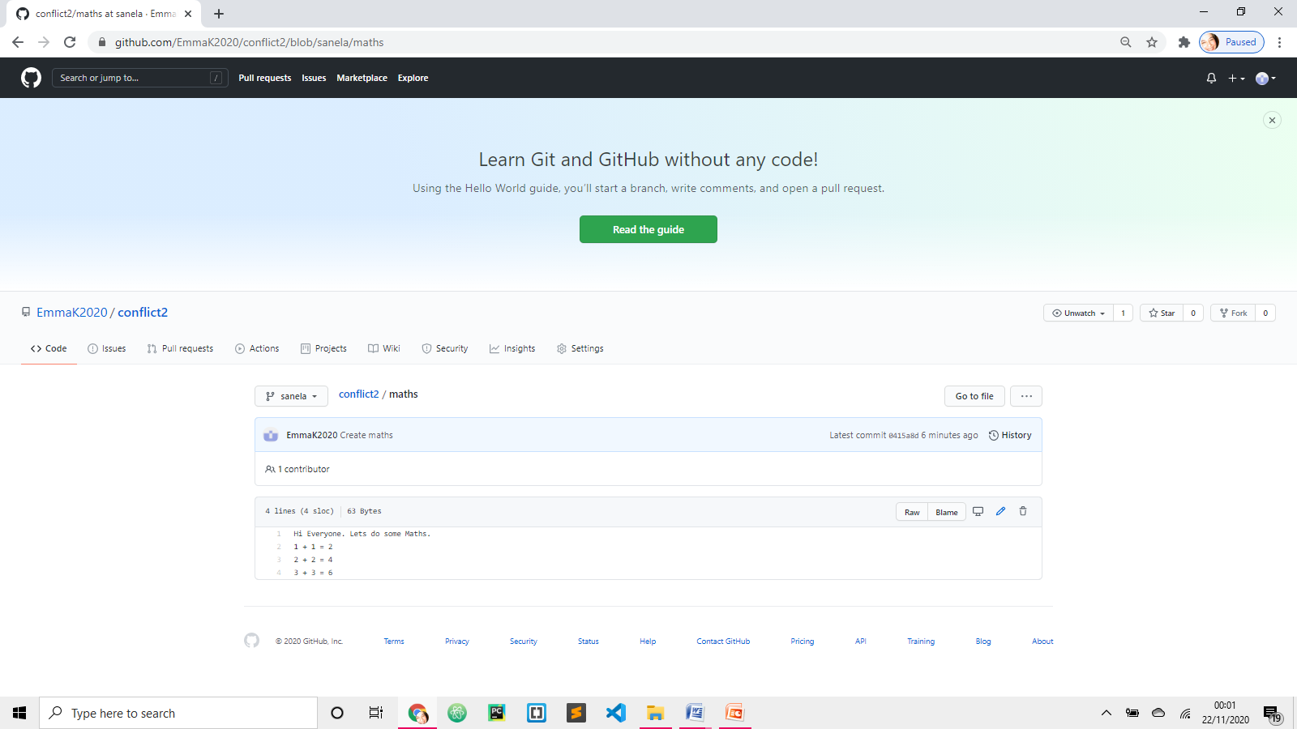

Click on maths file, click on pen.

Change 2 + 2 = 5

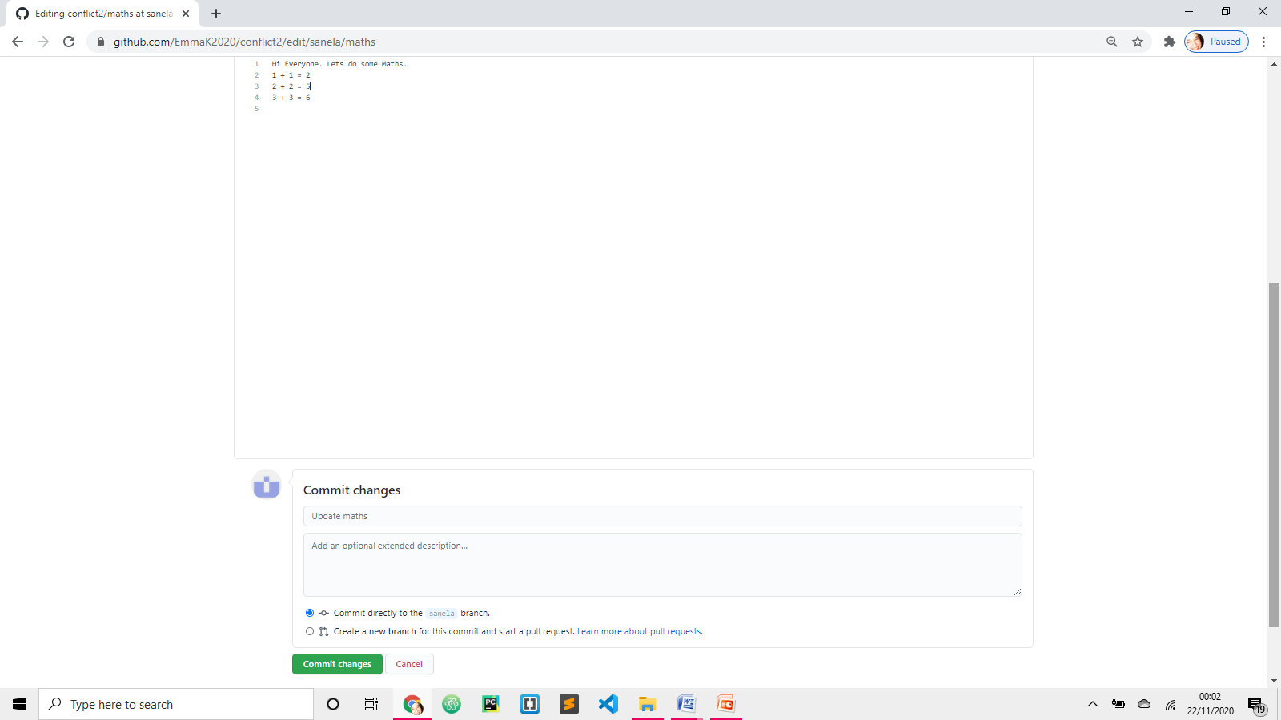

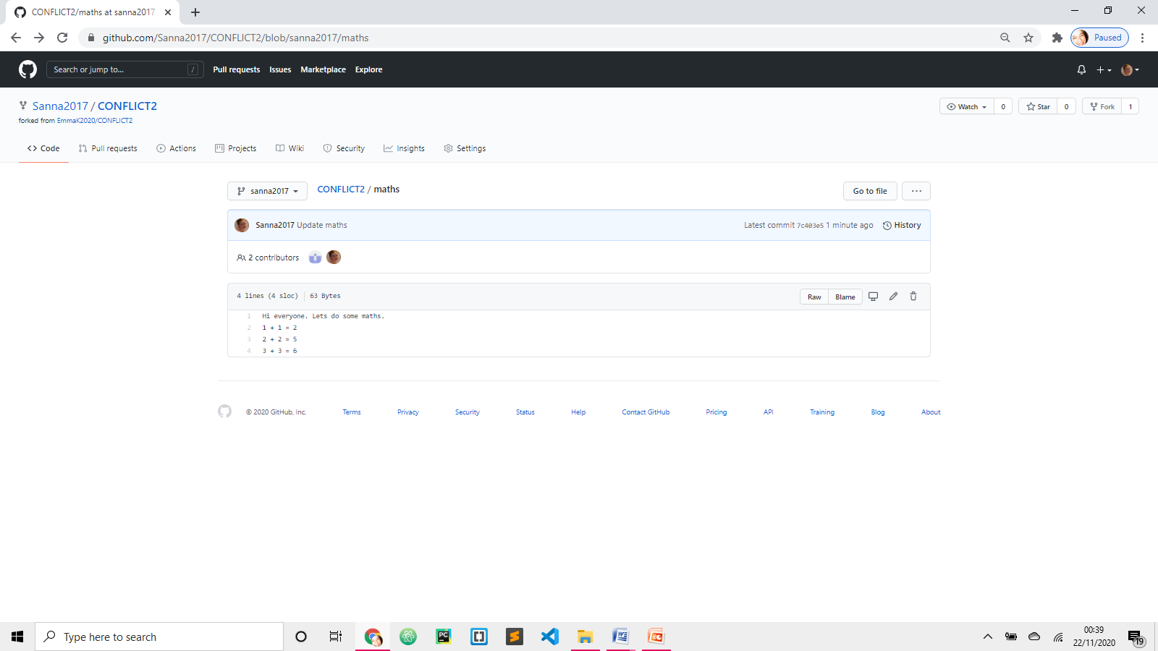 Go back to project

PART 4 – Pull request

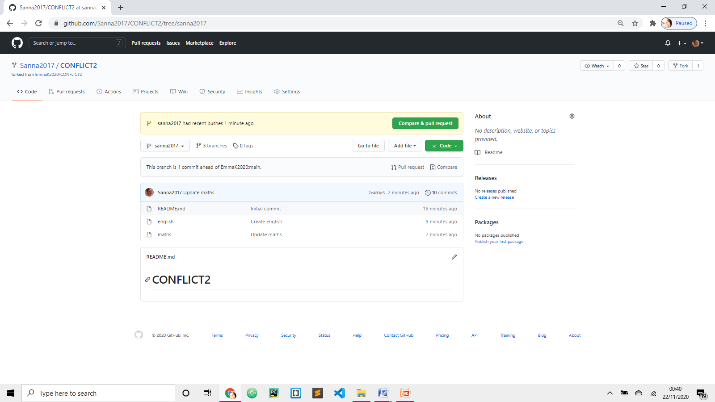

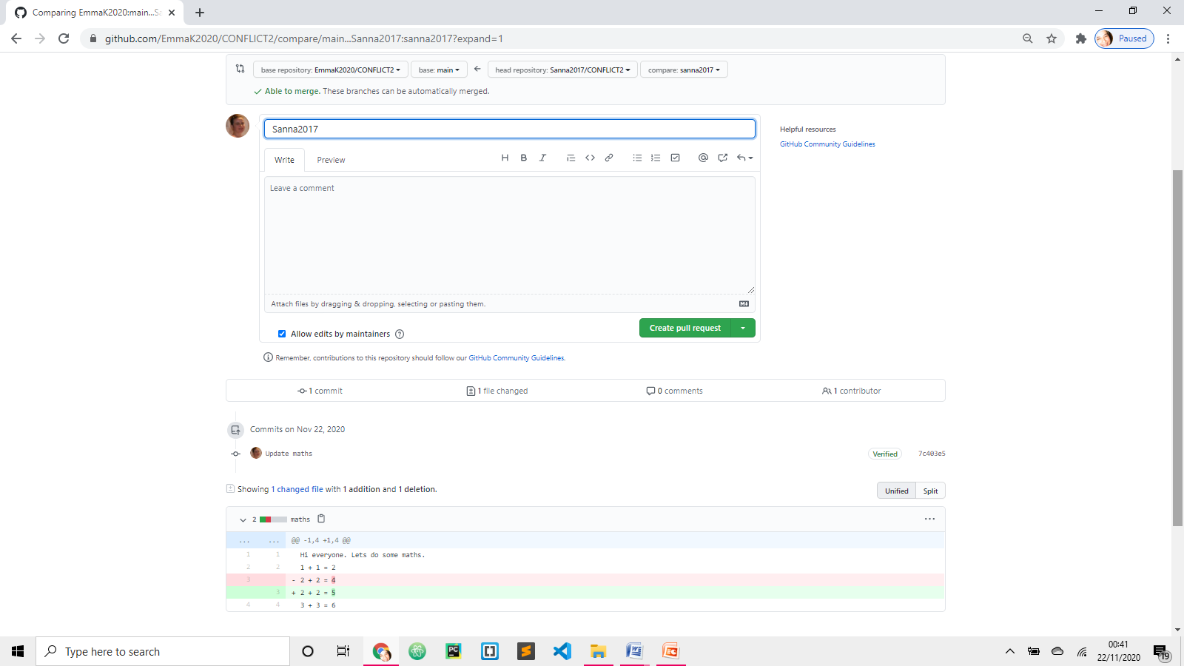

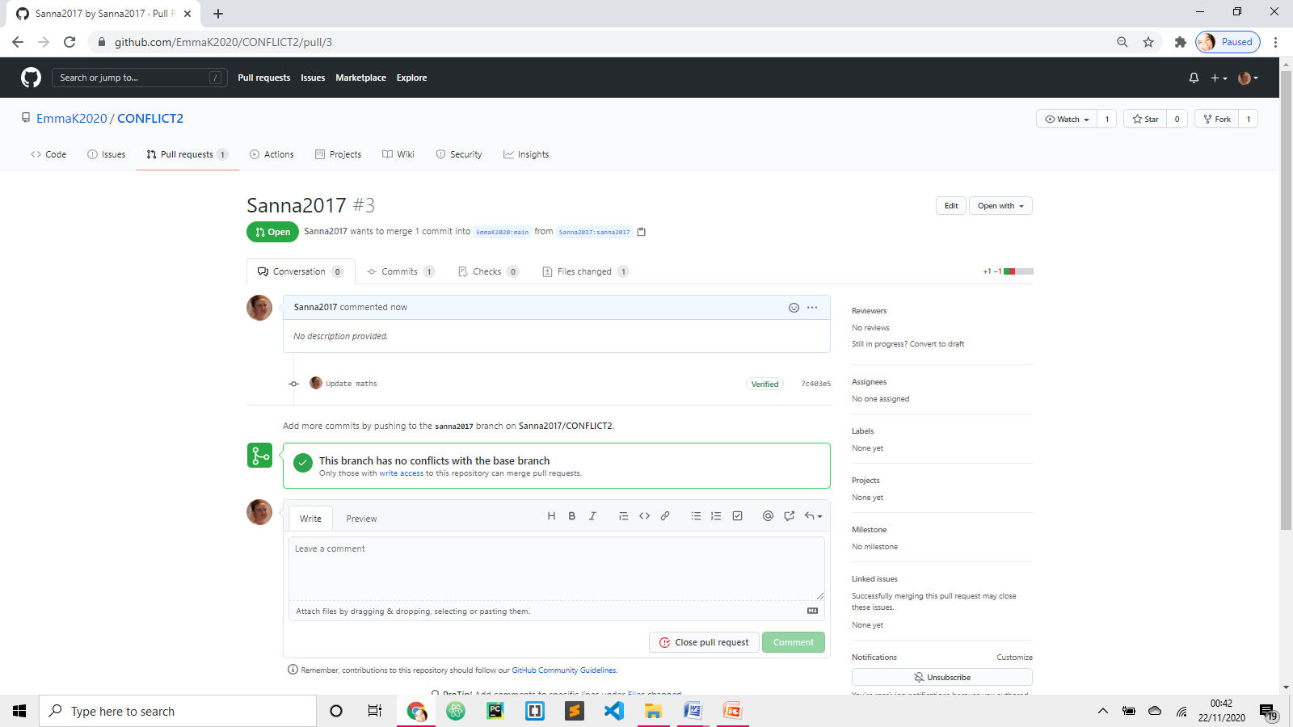

**Ade 12345678**

PART 5 – Ade, repeat parts 2, 3 and 4. Changes on your branch are:

* amending file “maths” 2 + 2 = 8
* delete file “english”
* Pull request

**EmmaK2020**

PART 6 – deal with requests

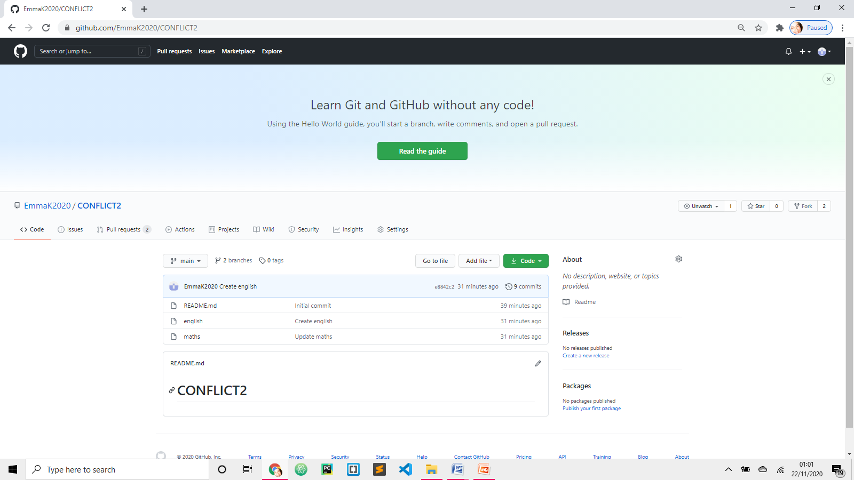

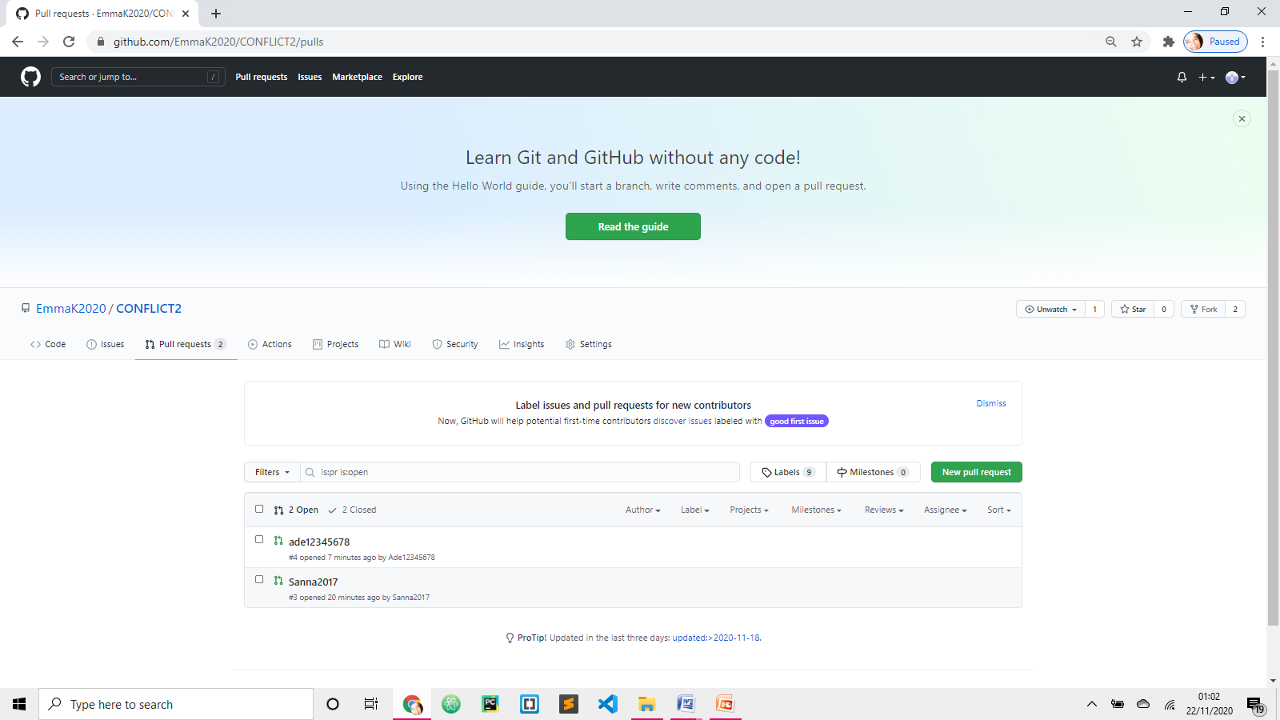

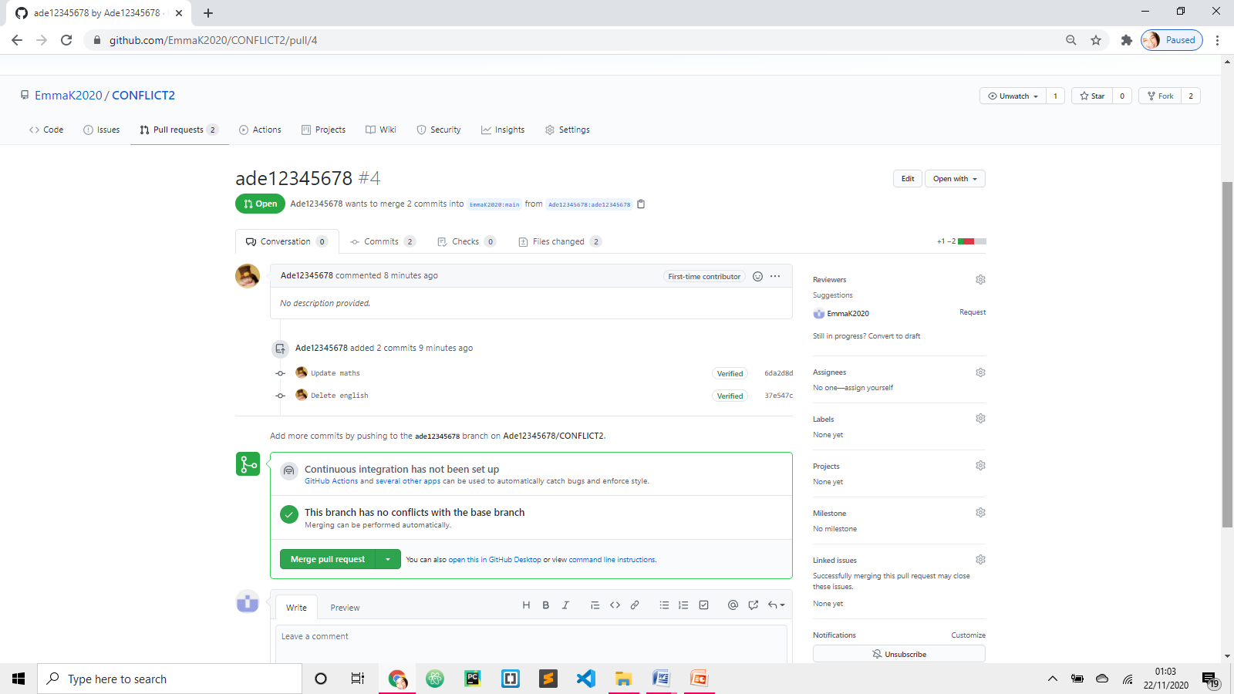 Open Ade’s request and MERGE

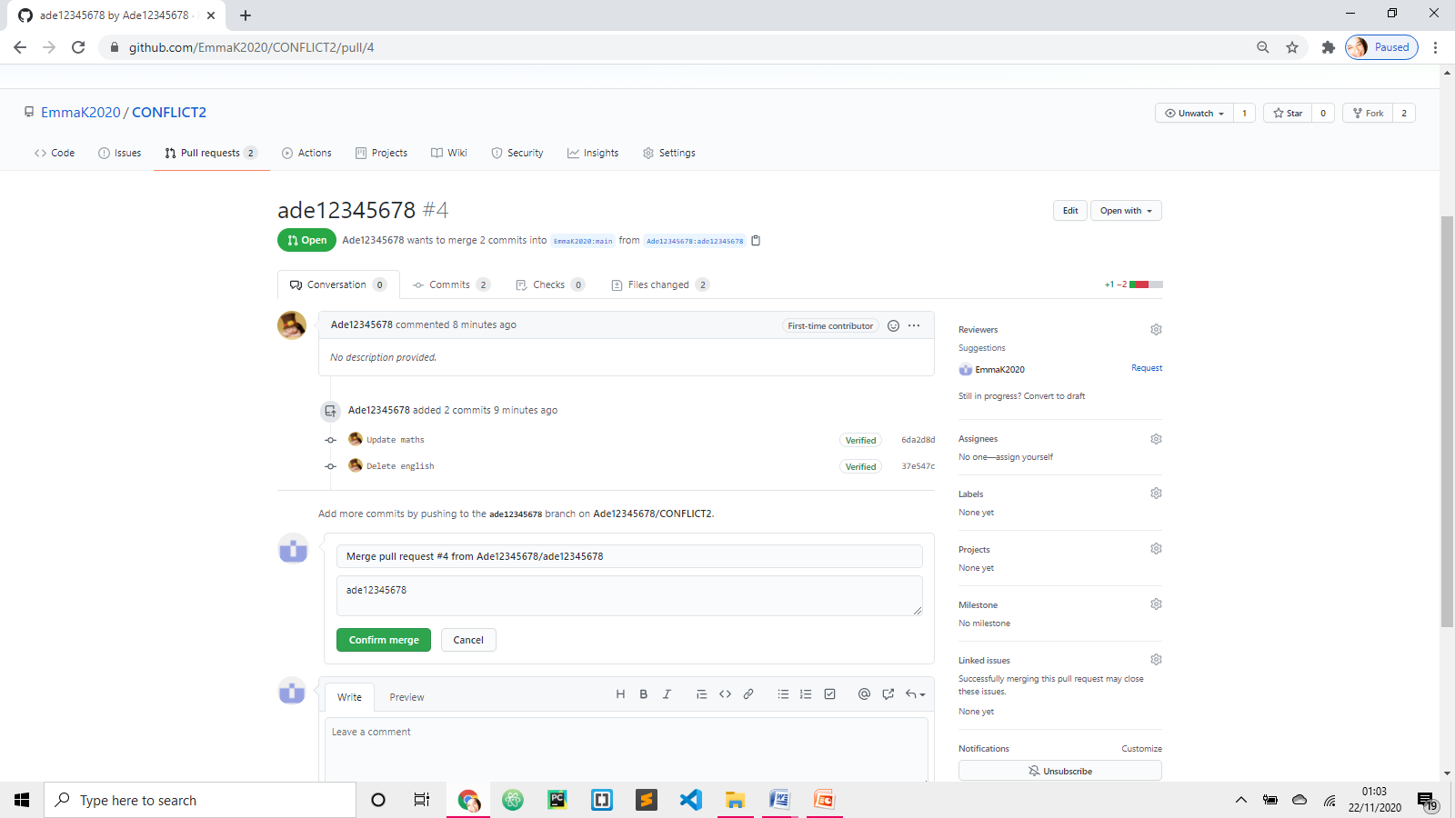 Confirm merge

Ade deleted Eng file and changed maths 2 + 2 = 8.

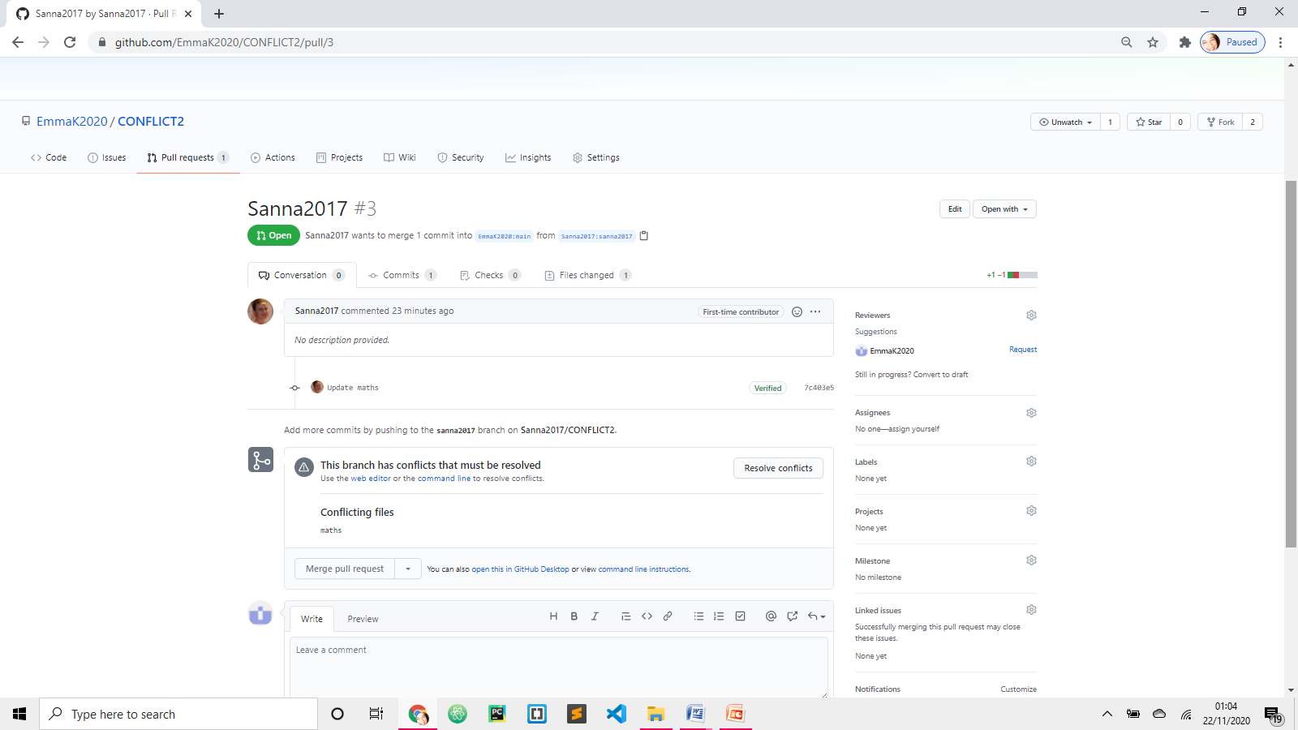

When Sanna’s request opened, it has CONFLICT. Resolve conflict!

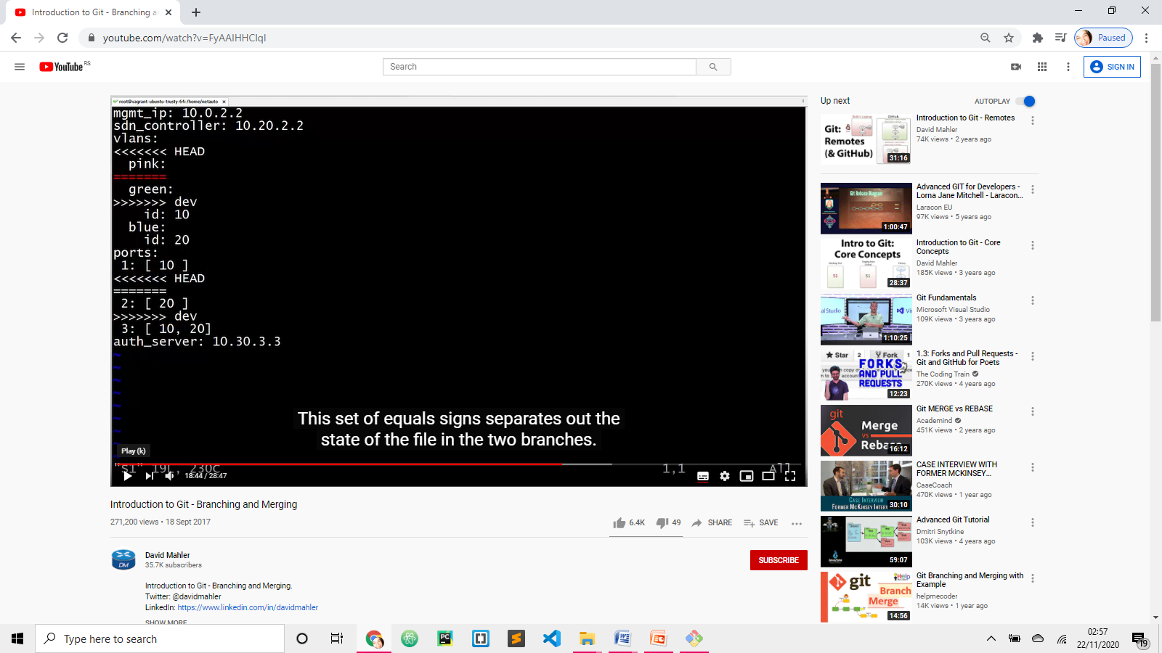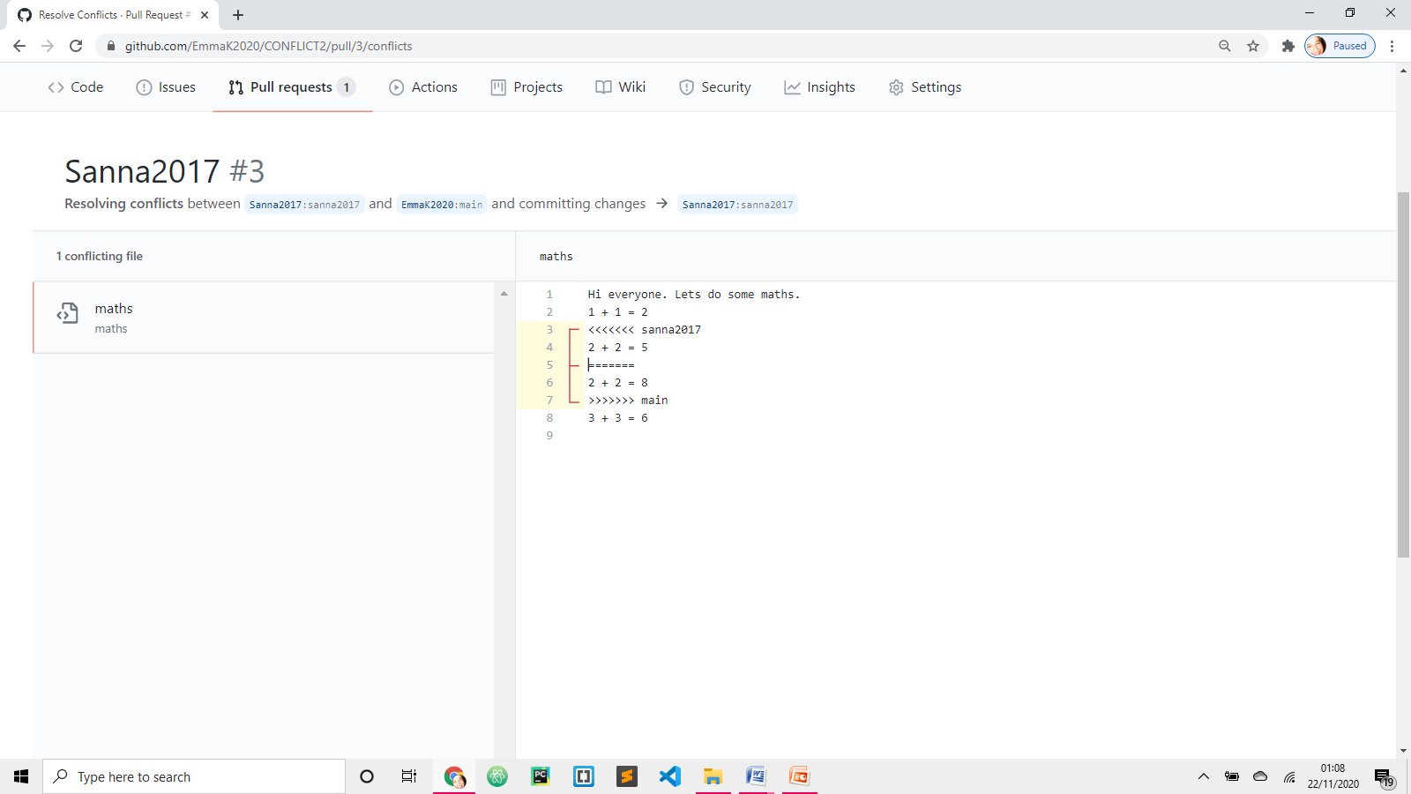

Do you want to keep Ade’s solution (main – it is not called Ade as it has already been merged with master/main) or Sanna2017.

Delete one of the solutions, delete <<<<<, delete ========.

**Delete Git marker: equals and brackets**

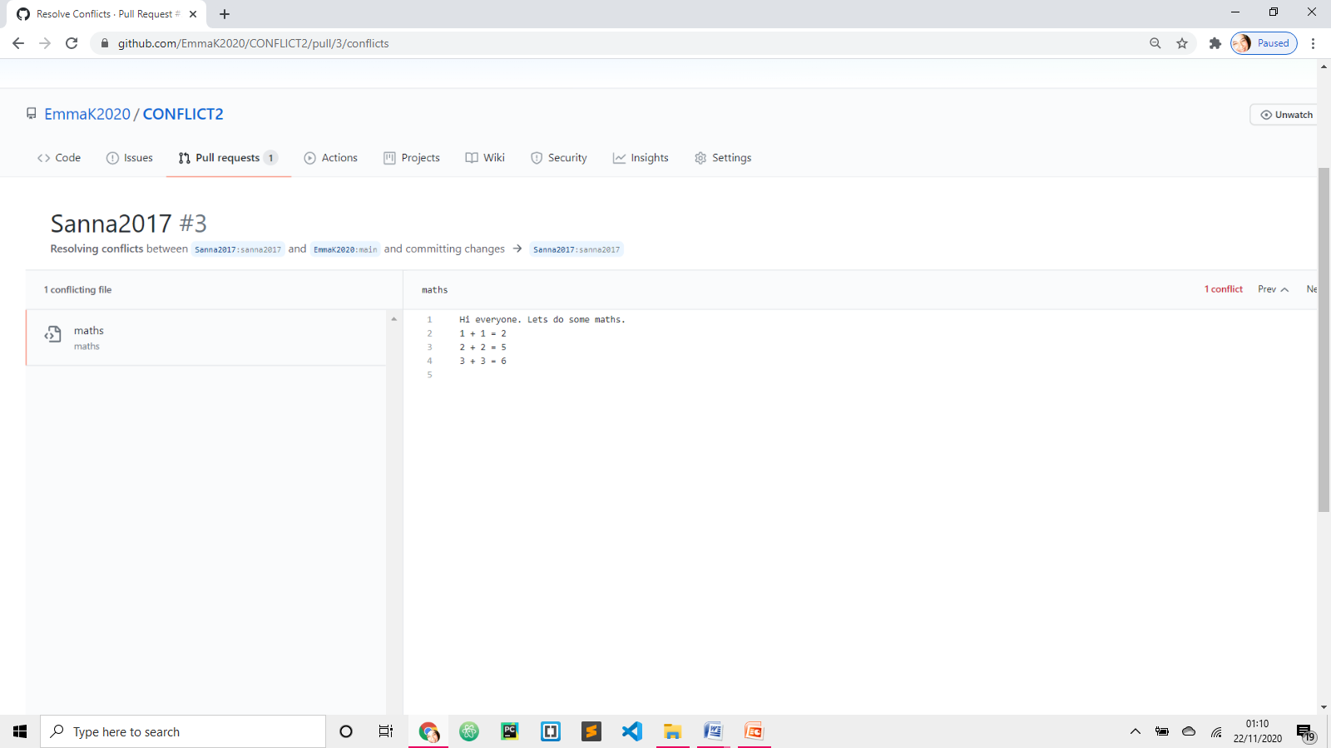

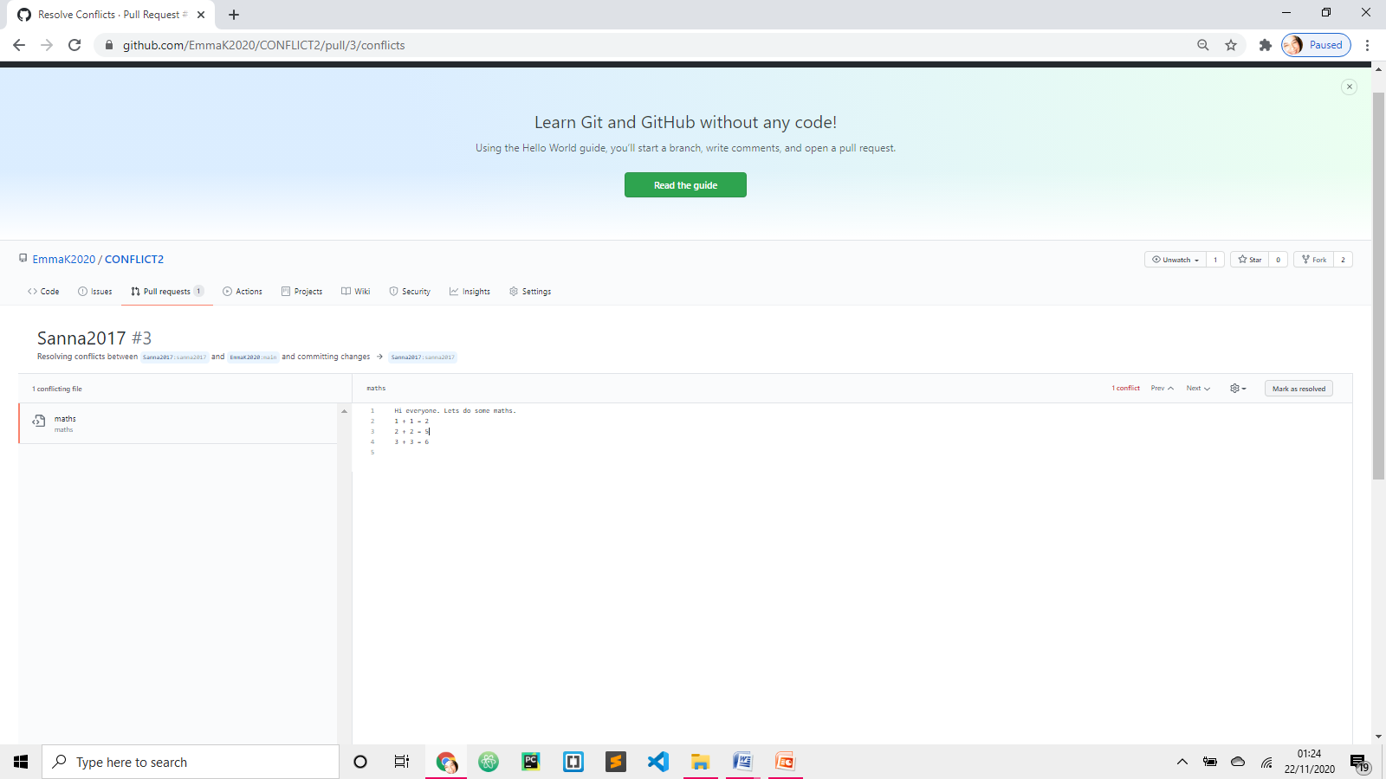

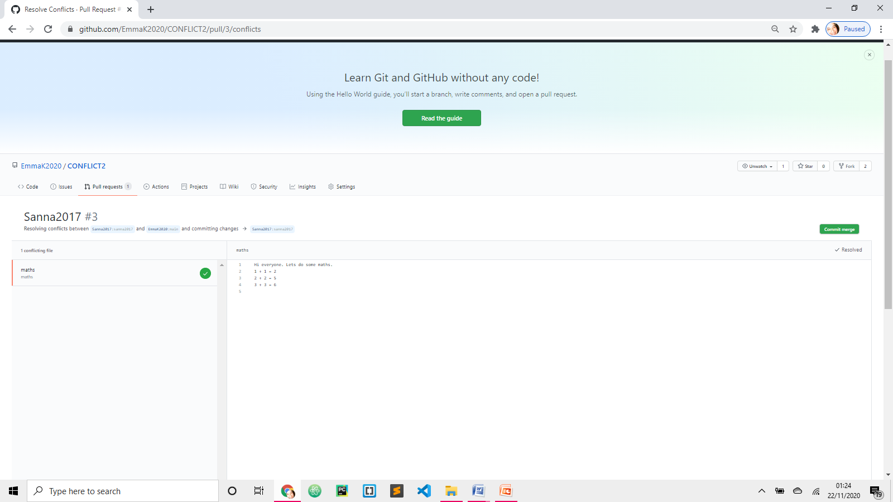 Have to **commit** first

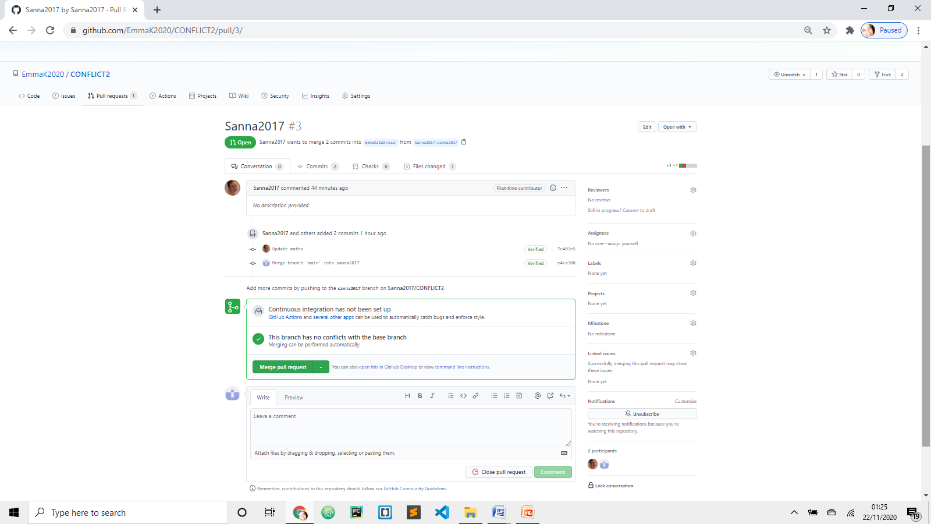

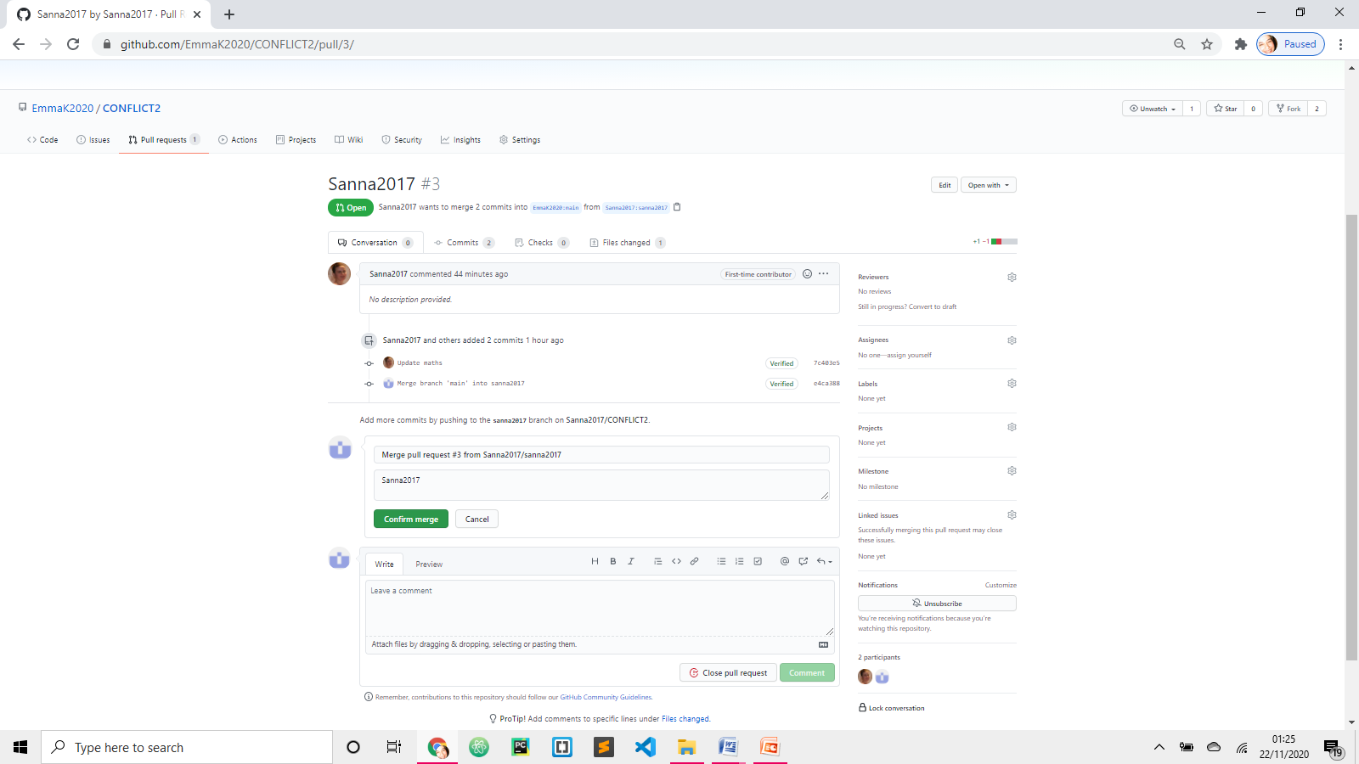

CHECK

Go to Conflict2 project and check if:

* English file has been deleted
* Maths file amended 2 + 2 = 5

